50 years of SCUBAPRO Regulators
Welcome to the timeline of SCUBAPRO regulators. This timeline traces the history of all first and second stages manufactured by SCUBAPRO in its first 50 years of history.
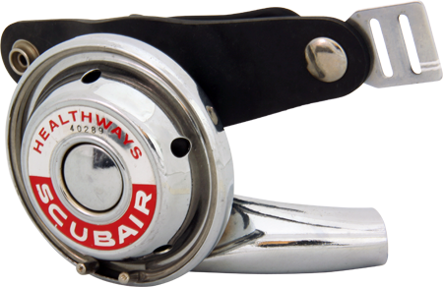1961 — 1962

Healthways Scubair Sonic
The Healthways Scubair Sonic and Scubair J were the forefathers of the early SCUBAPRO regulators, they were made of chrome-plated brass. This was the technology and brand from which the SCUBAPRO line stems. SCUBAPRO was in fact the trade name of the professional line of diving equipment that Healthways commisioned Gustav Dalla Valle and Dick Bonin to create. Soon after Healthways went bankrupt and Dalla Valle and Bonin bought the rights to the SCUBAPRO name and went on to create brand new equipment, thus a legendary brand was born in 1963

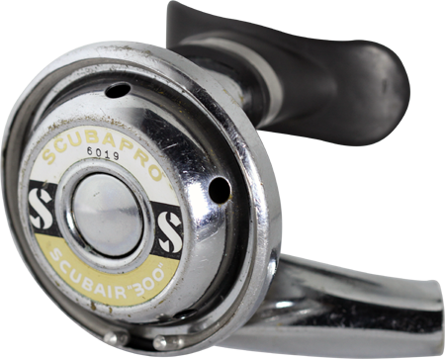1962 — 1963

SCUBAPRO Scubair 300
SCUBAPRO SCUBAIR “300” was designed by Healthways, and labeled SCUBAPRO, in 1962.
This was the first time that the name SCUBAPRO was used on a regulator

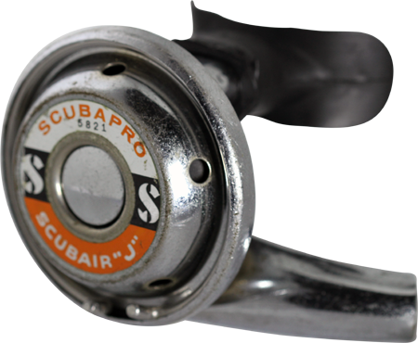1962 — 1963

SCUBAPRO Scubair J
SCUBAPRO SCUBAIR “J” was made entirely of chrome-plated brass, including the exhaust tee, with a SCUBAPRO sticker on the front cover. The SCUBAIR “J” appeared in the 1963 SCUBAPRO catalog

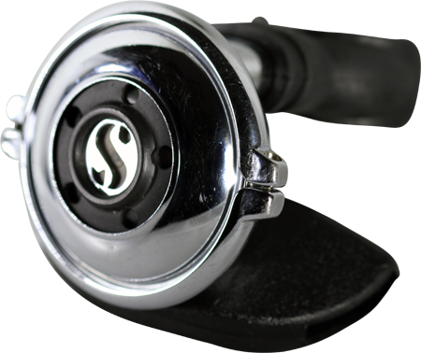1963 — 1988

080, 108, 080 HP
The 108 is the first SCUBAPRO second stage regulator wholly produced by SCUBAPRO. They were made of chrome-plated brass with a black rubber exhaust tee and were available to the public from 1963 - 1988. The simple valve design is so efficient that this basic design is still being used today. In later models the static orifice was upgraded to an adjustable type and the exhaust port was enlarged. This version was designated the 080 HP (High Performance) and was sold in combination with the MK2 first stage. The combo was indicated as "Mark2" in the catalogues.

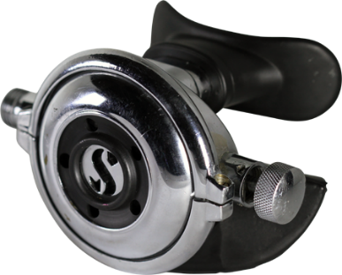1969 — 1986 Adjustable 109, R109 The Adjustable 109 is chrome-plated brass with a black rubber exhaust tee and was introduced in 1969. It was on the market until 1985. It is the first regulator to offer the consumer a means to adjust the inhalation effort of the regulator. The regulator breathed so easily that if you were headed into a strong current you could adjust it to prevent a free flow

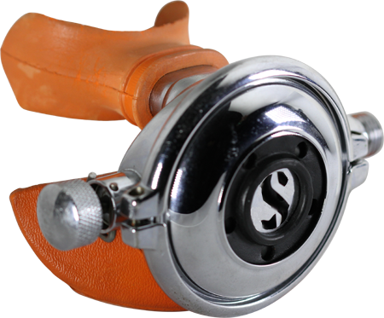1977 — 1978 Left Handed 109 Octopus This very rare regulator was only produced in 1977. It is designed to be used with the LP hose coming over the diver's left shoulder and is the first regulator that SCUBAPRO offered specifically configured as an Octopus. The Adjustable 109 used the same orange mouthpiece and exhaust tee as the Octopus version of the 080HP

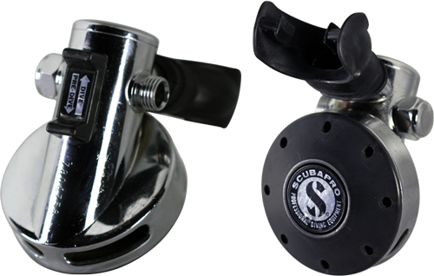1977 — 1978

Pilot
The Pilot regulator was actually designed by an engineering student as a class project. SCUBAPRO picked the regulator up from him and it became the best deep diving regulator ever made.The Pilot regulator is the only American made Regulator with a servo operated second stage. This “pilot valve” system provided an extremely high air flow and was very easy to breath, especially at the deeper depths. The valve is actually two valves; one valve pilots the other and was extremely revolutionary. The U.S. Navy used this regulator for their record deep dives in 1979, rating the Pilot as the best deep diving regulator. They presented SCUBAPRO with a plaque now proudly displayed at SCUBAPRO USA headquarters in El Cajon, CA
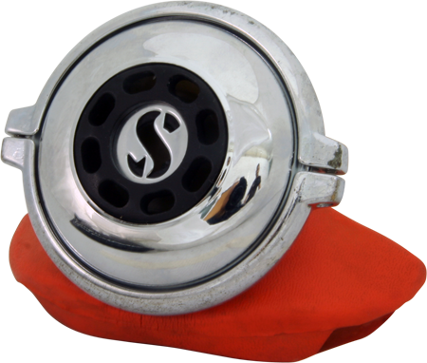1978 — 1988

108 octopus
The octopus version of the 108 had an orange exhaust tee and mouthpiece
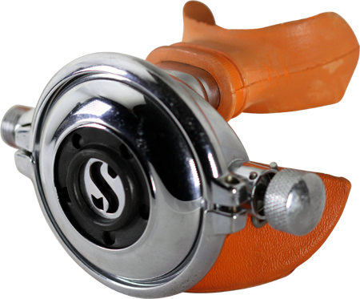1978 — 1985

109 octopus
The Adjustable 109 was offered as an Octopus between 1978 and 1985, with the same orange mouth piece and exhaust tee as the 108

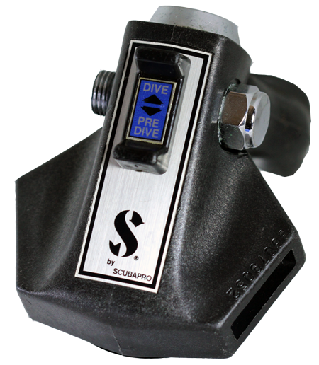1979 — 1990

AIR1
The Air1 is the successor to the Pilot using a pneumatic balanced valve system instead of a pilot valve. It was much less complicated to maintain compared with the Pilot, yet still provided the same ease of breathing that the Pilot offered. It was on the market from 1979 – 1990. The Air1 is the first SCUBAPRO regulator to be made of a material other than chrome-plated brass. The black composite material (polyester fiberglass) and the shape of the Air1 earned it the nickname of the “Darth Vader” regulator

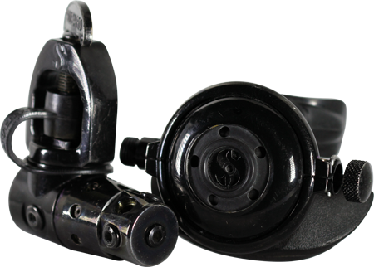1981 — 1990

MK5 Military
The black chrome plated version of the MK5 regulator, a combination of a MK5 first stage and an R109 second stage, was produced for the Italian Navy and a few hundred pieces were also sold to the public
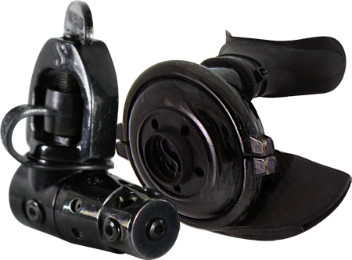1981 — 1990

MK4 MIlitary
A "military" version of the MK4 was also produced. It was a combination of a MK5 first stage with a 108 second stage, both with a black chrome finish

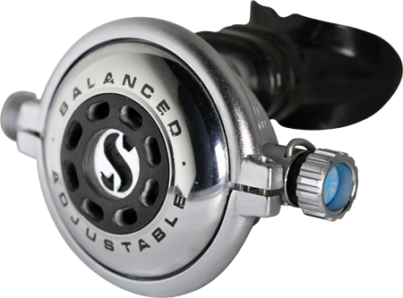1985 — 1994

Balanced Adjustable
The Balanced Adjustable was the first second stage regulator to offer air balancing. It was on the market from 1985 to 1997. Air balancing technolgy allowed SCUBAPRO to use a lighter spring on the lever which reduced the amount of pull required to open the air valve. The body of the regulator was made of chrome-plated brass with a black exhaust tee. The cover ring had Balanced Adjustable written on it and the rubber diaphragm cover had oval shaped holes in it rather than the round holes that were in the 108 and 109
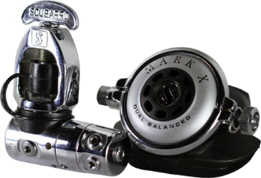1985 — 1986

MK X Dual Balanced
The Mark X second stage is a Balanced Adjustable that was sold as a combination first and second stage. It has “Mark X Dual Balanced” printed on the front cover ring instead of Balanced Adjustable. The cover also had a matte finish rather than polished chrome. This regulator system was available in Europe only
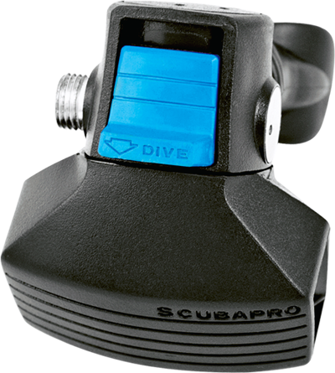1986 — 1990

D300
The D300, another “Darth Vader” style regulator, was available from 1986 to 1990. It also uses the same valve as the Air1 while the cover is entirely made of rubber, which made the purge valve very easy to access. The D300 had no external markings to identify it. The Dive/Predive switch was blue. Beginning in 1998 a red switch button was offered as an option and a teal option was offered beginning in 1990
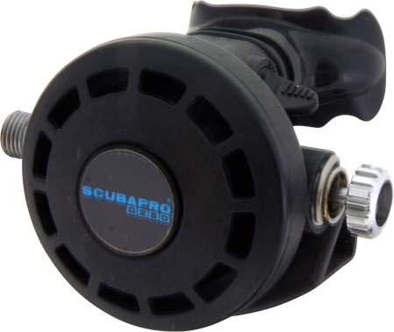1986 — 1987

G250
The G250 is the number one selling and most copied second stage of all time in the world. It was introduced in 1986 and was available until 2012 as the G250V (Vintage). The G250 is also considered to be the best all around regulator ever built. The G250 was the first regulator to introduce the adjustable VIVA (Venturi Initiated Vacuum Assist). The function of the VIVA is that it accelerates the speed of the discharged air to the point of zero effort. The G250 came in several different configurations. This regulator has the same basic valve as the Balanced Adjustable but is in a fiberglass reinforced polyester case rather than chrome-plated brass.

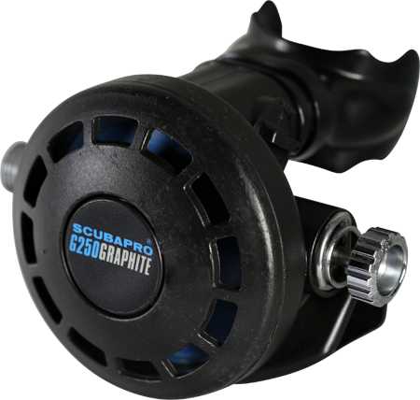1987 — 1988

G250 graphite
G250 Graphite was introduced in 1987. The housing was amorphous polyamide reinforced with fiberglass and graphite. This lowered the weight to 248 gr / 8.75 ounces. These new cases had a much better internal aerodynamic design which directed the airflow more efficiently towards the mouthpiece. The appearance was the same as the previous G250, except for the purge button sticker which read SCUBAPRO with G250 Graphite below.
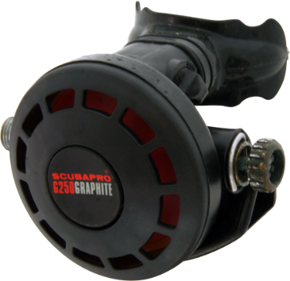1987 — 1988

G250 graphite octopus
There is an octopus version of the G250 that was available from 1986-1988. This version had an orange mouthpiece and an orange diaphragm.
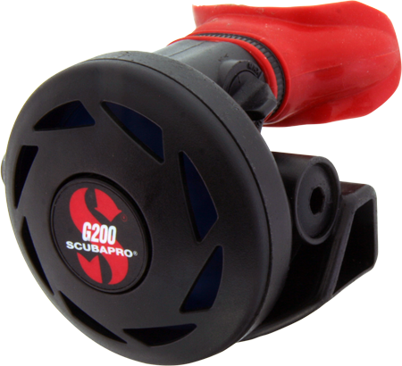1988 — 1995

G200 Red option
The original G200 diaphragm was blue with a blue sticker on the purge button but there were also optional color kits with a red or teal diaphragm and a matching purge button sticker color.
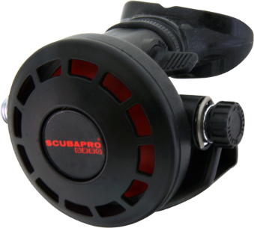1988 — 1989

G250 Red option
In 1989 SCUBAPRO introduced a Red and Teal option that consisted of a red or Teal diaphragm with matching stickers. In 1990 the Adjustment Knob became a combination of metal and plastic and the purge button sticker had SCUBAPRO with G250 below it
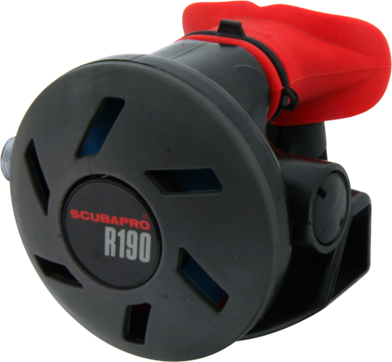1988 — 1990

R190 Octopus
The first version of R190 also existed in an octopus version, easily recognizable by its red mouthpiece and purge button graphics.
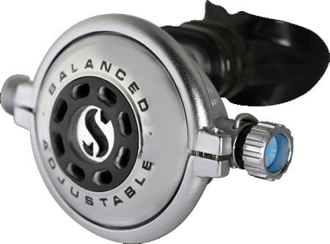1990 — 1997

Balanced Adjustable
The Balanced Adjustable was offered in a polished chrome version, and also in a rarer satin version.
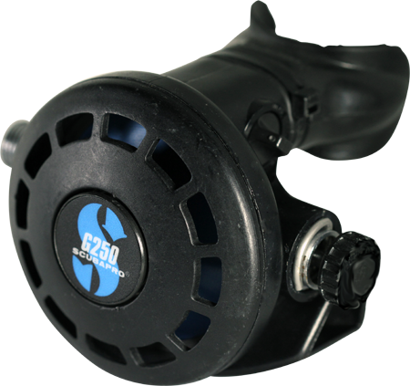1990

G250
The G250 went through several versions which often differed only in appearance, such as this one.
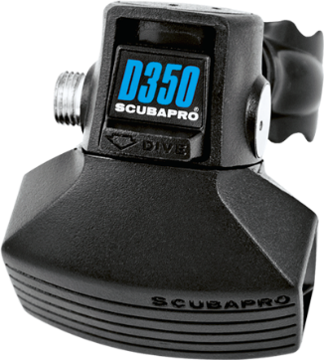1991 — 1993

D350
The D350 was produced from 1991 to 1993. This is another of the “Darth Vader” regulators. The poppet was redesigned to make the regulator easier to maintain and provide a larger volume of air with each breath. The intake lever was also reversed from the way it was in the D300. The front of the Dive/Predive switch had a sticker designating it as the D350.

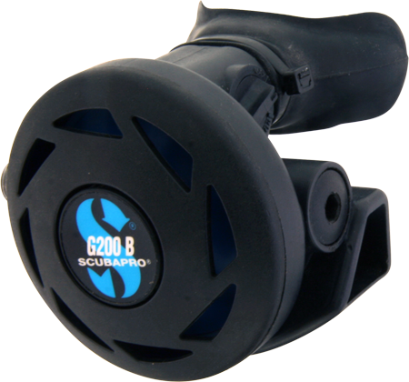1991 — 1998

G200 B
The G200B second stage was an air balanced version of the G200 which was available from 1991 until 1998. The valve system is basically the same as the Balanced Adjustable, but it also had the VIVA assist like the G200. The G200B is a close cousin to the more well-known G250 which was an adjustable, balanced second stage. Like the G200, the G200B came from the factory with a blue diaphragm and sticker and optional red or teal diaphragm and sticker colour kits were available.

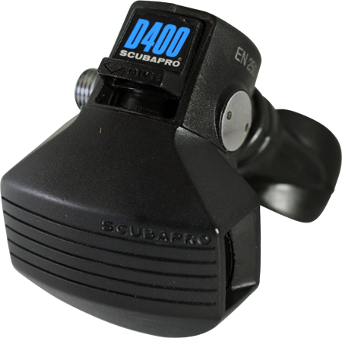1994 — 2002

D400
The D400 is the last of the D series regulators and the last to use this unique valve system. This great regulator was available from 1994 – 2002. This “Darth Vader” style regulator had a D400 Sticker on the Dive/Predive switch. The volume of air was again increased with each breath by redesigning the lever. The D400 also had a red or teal sticker available

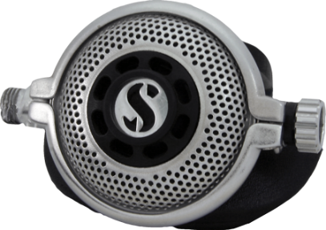1998 — 2000

Balanced Adjustable
The Balanced Adjustable was offered with a perforated cover which was sold only in the Asia-Pacific market

PLUS MANY MORE NOT LISTED HERE

